Interactive research for production and work development

Jörgen Eklund#*, Jostein Pettersen*, Mattias Elg*, Andreas Bolling*

*Helix Vinn Excellence Centre and IEI, Linköping University, SE 581 83 Linköping, Sweden
#Division of Ergonomics, Royal Institute of Technology, Alfred Nobels Alle 10, SE 141 52 Huddinge, Sweden, e-mail jorgen.eklund@sth.kth.se

Abstract
Interactive research performed as a collaborative approach in conjunction with organizations is considered a new and promising alternative to other research approaches. The purpose of this paper is to describe how interactive research could be used in the interaction between researchers and organizations when running projects to develop production systems and work performed in these systems. It also aims to identify advantages and disadvantages when applying interactive research. Two long term interactive research projects, organised in collaboration with the partnership of Helix Vinn Excellence Centre at Linköping University were performed and data were collected from documentation of interactive seminars, from notes and from interviews with key actors. Interactive research offers several advantages in comparison with traditional research approaches, foremost higher practitioner involvement and validation opportunities of the results. There are also several difficulties, foremost the need of extensive resources and competencies for the research. The overall experiences from participating practitioners were that they considered that the discussions had been useful, stimulating and interesting, and that the fast feedback from data collection was appreciated. One crucial issue is to what extent this interactive research approach may contribute to high quality research, or to what extent the pressure from the practitioners for actionable practical results will take over.

Keywords. Interactive research, production development, organizational change

1. Introduction
A number of research approaches have been proposed over the years in order to improve existing research practices and to overcome problems and criticism. The new approaches proposed have been subjected to new problems and disadvantages. Case study research is performed under different conditions compared to other forms of research. Action research introduced the practitioners as important stakeholders in the research process, and to a large extent redefined the role of the researcher. However, the application of action research was criticized for putting too much effort on the practical change and too little focus on the knowledge creation process (Svensson et al., 2007a). In order to better meet the demands on academic output in terms of knowledge creation and theory building, Interactive research was proposed as a further development (Ellström et al., 1999; Svensson et al., 2002; Aagaard Nielsen & Svensson, 2006).
The CMTO model for interactive research is based on the assumption that there is a clear division of interests, responsibilities, powers and expertise between researchers and participants within the framework of the collaboration that takes place. These differences should also be clearly reflected in the division of work and roles between them. The point of departure is that there is a practice system and a research system, and that these two systems interact with each other. The participants from the practice system and researchers meet initially to discuss, negotiate and decide on the issues that the two parties are interested in examining, and to jointly define the issues that both parties are interested in. These common issues of interest govern the researchers’ choices regarding the theoretical reference framework and choice of methods. The issues of joint interest are investigated by the researchers who collect data and analyze the data. The results are discussed, interpreted and conceptualized in a joint process where the practitioners and researchers meet. Responsibility for taking action and implementing practical operational changes lies with the participants from the practice system. The knowledge that has been created from the interactive process may be implemented in the practice system. This allows a new discussion to be held between the researchers and the practitioners to define the new issues of joint interest. This may lead to a new round of data collection, analysis and joint conceptualization in accordance with the model presented in Figure 1. In other words, the model aims for a thorough evaluation of research issues for selection of those with highest practical and scientific relevance, allowing only the most interesting issues that also are of joint interest to be researched. It also aims for producing research results of good scientific quality and also practically applicable knowledge as a basis for concrete measures.

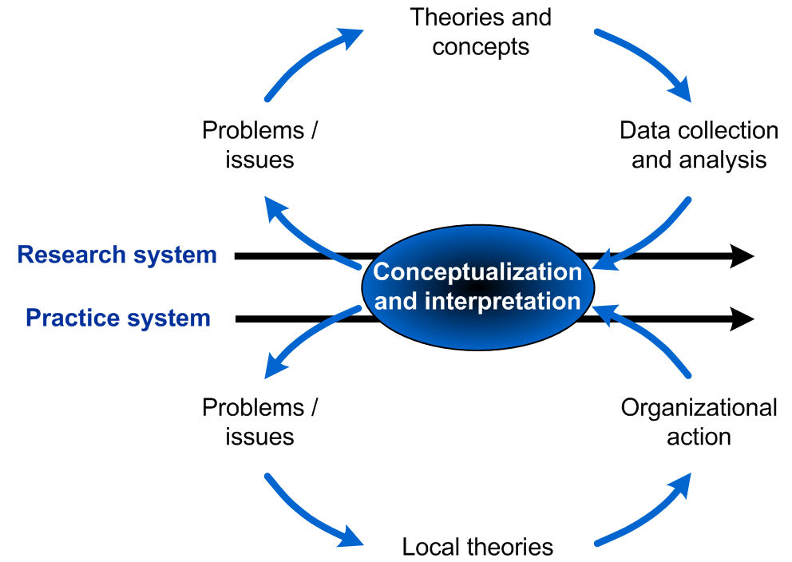

Figure 1. The CMTO model of interactive research, modified from Ellström et al. (1999)

2. Aim
The purpose of this paper is to describe how interactive research could be used in the interaction between researchers and organizations when running projects to develop production systems and work performed in these systems. It also aims to identify advantages and disadvantages when applying interactive research.

3. Method
This paper is based on two long term interactive research projects, organised in collaboration with the partnership of Helix Vinn Excellence Centre at Linköping University. Data were collected from documentation of interactive seminars, from notes and from interviews with key actors (compare Svensson et al., 2007b). The analysis focused on identifying advantages, disadvantages supporting factors and obstacles in the application of the interactive research approach.

4. Results and discussion
The projects were organised as described above. The driving force was in both cases a joint seminar series, including e.g. aim / problem definition, literature seminars, benchmarking seminars, planning seminar, result discussion seminar, implementation seminar, evaluation seminar and dissemination seminar. The seminars included private and public organizations, management and union representatives. The collaboration was aimed to be performed on as equal power basis as possible, including an open dialogue and mutual respect. Discussions took place in an open climate and with high acceptance of differences in opinions.
The interactive research approach offers several advantages. It creates a forum and a meeting point between different stakeholders which does normally not exist elsewhere. It makes the perspectives of the local knowledge versus the generalised knowledge derived from research visible. Further, it offers opportunities to validate the joint knowledge that has been formed in the process. Access to organisations are improved, since it ensures that the research dealls with issues of high interest for the stakeholders, and that feedback is built into the research process.
However, this research approach is not free of difficulties and risks. First, there are several contradictions between the perspectives of the practitioners and the researchers. The time horizon is longer for the researcher than the practitioner. For researcher, the demands on reliable and valid results have highetst priority, which is not the case for the practitioner. As a consequence, the focus on methods and methods usage is stronger for the researcher. On the other hand, the demands for actionable results are higher for the practitioner. The logics of production creates a situation in which the performance pressure is higher for the practitioner. This means a continuous pressure from the practitioners on actionable results.
Another disadvantage is the difficulty to follow the projects on a long term basis, and the limited opportunities to include new research issues during the course of the project before the original issues have been finalised. The researchers perceived the difficulty to get continuity among participating practitioners in the group. Some changed jobs, were on sickleave or retired and others joined instead. As a result, the group processes were disturbed and the pace of progress was hampered.
One obvious disadvantage is the substantial demand for time and economic resources. It is necessary and it takes time to build up mutual confidence, especially since the approach must be combined with critical discussions, something which may be difficult for many participants. Another obvious risk is that the interaction takes place over long periods of time and as a consequence strong relations with participants from the organization develop so that the researchers “go native” and lose their critical view. It may even be questioned to what extent a critical perspective may be present in some situations and to what extent the researchers have access to the critical events that take place in the organization.
Furthermore, the personality and experience of the researcher is not unimportant with regard to the ability to run this type of project. It is probably not a task that can be recommended to every PhD student, especially not if they are young and inexperienced. The qualifications of the researcher need to be much broader than in traditional reserach.

5. Conclusions
Interactive research offers several advantages in comparison with traditional research approaches, foremost higher practitioner involvement and validation opportunities of the results. There are also several difficulties, foremost the need of extensive resources and competencies for the research.
The overall experiences from participating practitioners were that they considered that the discussions had been useful, stimulating and interesting, and that the fast feedback from data collection was appreciated. One crucial issue is to what extent this interactive research approach may contribute to high quality research, or to what extent the pressure from the practitioners for actionable practical results will take over.

5. References
Aagaard Nielsen, K. & Svensson, L. (Eds). (2006). Action and Interactive Research. Maastricht: Shaker Publishing BV.
Ellström, P-E., Eklund, J., Kock, H., Lindström, L. & Melin, U. (1999). Knowledge Creation Through Collaborative Research: An Emerging Model. Paper presented at HSS -99, March 16-18 1999, Falun.
Svensson, L., Brulin, G., Ellström, P-E., Widegren, Ö. (2002). Interactive research – for development of theory and practice. Stockholm: The National Institute for Working Life.
Svensson, L., Aronsson, G., Randle, H. & Eklund, J. (2007a). Hållbart arbetsliv – projekt som gästspel eller strategi i hållbar utveckling. Malmö: Gleerups.
Svensson, L., Eklund, J., Randle, H., & Aronsson, G. (2007b). Interactive Research – an Attempt to Analyse two Change Programmes. International Journal of Action Research, 3(3), 250-277.

