The application of the ergonomic screening-tool AAWS to support design engineers in product and process development

Gabriele Winter, Karlheinz Schaub, Ralph Bruder, Kurt Landau

Institute of Ergonomics, Darmstadt University of Technology,
Petersenstrasse 30, 64287 Darmstadt, Germany

Topic: Risk assessment at work

Keywords: Assembly work, work related muscular-skeletal disorders, ergonomic risk assessment, vehicle development process

Abstract
In automotive industry assembly work is characterized for example by unfavorable working posture, action force and material handling. Despite of new technologies and technical aids, physical workload still plays an important role in assembly lines. Ignoring ergonomic principles in planning and developing product processes results in physical stress and discomfort at workstations at the shop floor level. Risks exist, if the design of the work situation is not in accordance with ergonomic design principles. Vehicle geometry is responsible for imposed working postures in the form of (lateral) bending and twisting of the trunk and extension of the arms. Other factors can include the need to apply strong forces, unfavorable load-handling situations and extreme joint angles, in some cases aggravated by heavy stress on the finger-hand-arm system from application of strong action forces and repetitive movements. Disorders of the musculoskeletal system still are of a common occurrence throughout Europe. Hence the ergonomic process should be supported by risk assessment tools in the design process for the evaluation of the workers’ physical workload. The checklist AAWS (Automotive Assembly Worksheet) is used as an objective and practicable method to estimate physical workload and gives hints for bottlenecks of the assembly work. Meanwhile the screening-tool is applied for ergonomic risk analysis to support engineering teams by the product and process development.

Introduction
The ignoring of ergonomic principles in the planning and design stages leads to elementary errors in the design of workplaces. These errors lead to complaints and sickness amongst the workforce. It can be proven that in the automotive industries a human-oriented ergonomic workplace design can improve worker satisfaction and support the economic goals. Despite of new technologies and technical aids, physical workload still plays an important role in industry. In automotive industries much effort has been made to decrease the operators’ physical workload.

The screening-tool was tested and validated at the stations of the assembly lines with high ergonomic capability in automotive industry in Germany (Schaub 2003, Winter et al. 2006). Considering that proactive / constructive ergonomic design is most effective and least expensive in an early design phase (see fig. 1), an ergonomic worksheet was created with respect to physical work in assembly lines.

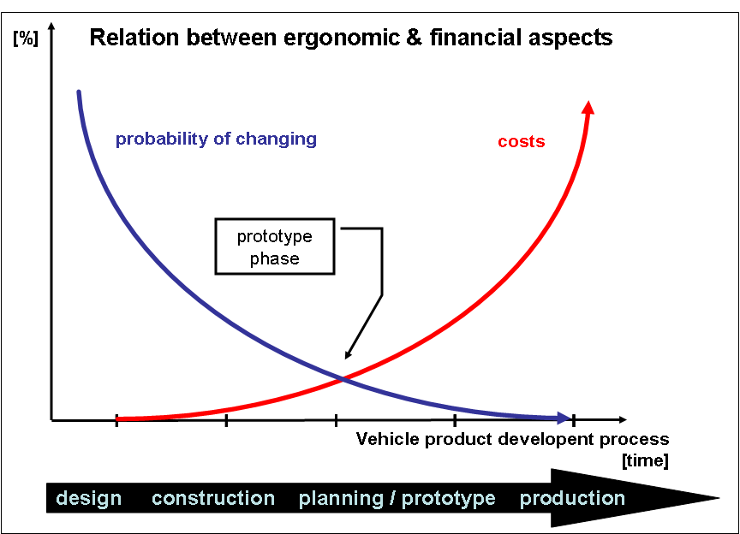

Fig. 1: Relation between ergonomic and financial aspects in product development process

Fig. 1 shows the relation between the capability of change and the costs in each development phase. The later any change the higher the costs. The IAD had developed the checklist AAWS in cooperation with several organisations to carry out an ergonomic risk assessment at the start of the vehicle development and planning process (Landau et al. 2004).

The screening-tool AAWS is a recently developed ergonomic design tool based on national and international legal requirements for health & safety at work with special reference to European legislation (e.g. EU-Machinery Directive, EU-Framework Directive). The checklist enables an evaluation of individual workstations with respect to their ergonomic design quality and to health related hazards. During the validation phase of the screening method, ergonomic improvements were introduced which brought a noticeable reduction in stress for some workstations (Schaub 2004). By using the method to evaluate assembly work the potential for design change was recognised. The communication between the planning phase and the development and construction phase was improved. An educational concept for AAWS has been developed which improves the communication between the various phases. The ergonomic potential for design was identified and it improved the vehicle development process.

Development of AAWS
The screening-tool AAWS was recently developed on the experiences in several joint research projects of the Ergonomics Institute, Darmstadt University of Technology (IAD) and German enterprises of the automotive industries (e.g. Adam Opel AG, Rüsselsheim and Dr.-Ing. h.c. F. Porsche AG, Stuttgart). For the different organisations special screening-tools were developed, e.g. to ensure ergonomic favorable conditions by means of standardized ergonomic problem tracking systems, linking plant and technical center activities. Besides these, the screening-tool should comply with national and international legal requirements for health & safety of work with special reference to European legislation.

AAWS is used for ergonomic risk assessments in the production phase as well as in early design phases and thus supports the ergonomics process. As it also meets the EU-legal requirements for the improvement of working conditions, the AAWS is a good example for a practical application of the dual European system of health & safety at work. Qualitative guidance to designers is offered by type A standards of the machinery directive, e.g. EN 292 (Safety of machinery; Basic concepts, general principles for design), especially chapter 4.9 „Hazards generated by neglecting ergonomic principles in machine design“ and EN 614 (Safety of machinery - Ergonomic design principles) especially chapters 4 “General principles” and 5 „Incorporating ergonomic design principles into the design process“). In Chapter 4.1 “Design considering anthropometry and biomechanics” the following qualitative guidelines are given for body dimensions: When designing work equipment to conform to the expected operator population, at least the 5th to 95th percentiles should be used. As equipment is designed for use by both men and women, the relevant percentiles for women and for men should be used (see EN 547-1). When determining clearance (such as those for leg room), 95th percentile values should be used. For reach (e.g. operator reach), 5th percentile values should be used. Where the work equipment dimensions are adjustable, “the range available should cover the 5th to the 95th percentiles ...”. In the same manner guidance is given for postures, body movements and physical strength. Quantitative guidance is offered by type B standards. Special reference was given to EN 1005 parts 1 to 5 which deal with manual materials handling, recommended force limits, working postures and movements and repetitive loads of the upper limbs during machinery operation.

Implementation of AAWS in an ergonomic design process
The screening-tool is used in an iterative design process resulting in a continuous improvement process. The application of the worksheet enables designers to decide the priority order of improvements. AAWS is used in different phases of the vehicle development: for ergonomic analysis of prototypes and for evaluating the production phase themselves. First the designers and planners orient themselves to the former reference model. It should be noted that a different database is used for each phase of the vehicle development process:
- Design phase: rough geometric data (digital data mostly)
- Constructions phase: detailed design data, finer geometric data, data of materials and their functions, location of parts, etc.
- Prototype phase: time analysis of the physical aspects of the future product, machinery, transport, handling and tools
- Production phase: using the planned procedures with limited possibilities to change the process
In the planning stage of prototypes each operation is considered separately. At the start of the iterative procedure an ergonomic evaluation is made with the screening- tool AAWS. The choosen work cycle (relation of planned components to materials, machines, tools, human resources) is investigated for the ergonomic situation. Based on AAWS risk assessment designers try to identify and eliminate the bottlenecks of the reference model. In the next step the operations are combined to make the assembly work less stressful. In this way different scenarios of assembly tasks are evaluated on the basis of design analysis and geometric data of the prototypes. Various examples to reduce ergonomics weak points give hints for product specification for designers.

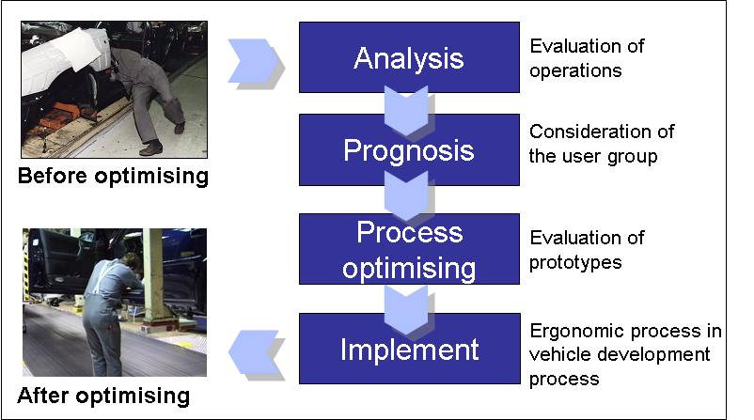
Fig. 2: Implementation of ergonomic evaluation in the vehicle development process

Fig. 2 shows an example of using and implementation of ergonomic evaluation in the design process. A database with good practices is built up to support designers in the vehicle development process.

Conclusions
The modified conception of the product (-components) and process is improved by the following results:

- Reducing physical workload in assembly lines,
- Reducing the working time in awkward postures (e.g. overhead work, lateral bending and bending forward),
- Using and evaluating technical tools and technologies to reduce action force,
- Reducing manual handling of heavy components,
- Reducing the input of materials and energy,
- Reducing process time,
- Increasing stability of production and process security.

The survey confirms the potential of ergonomically designed work processes with respect to legal requirements for ergonomic workplace design.

References

Landau, K.; Spelten, Ch.; Winter, G.: Nachhaltige und ergonomische Gestaltung von Industriearbeitsplätzen . In: Thema Forschung. Nachhaltige Gestaltung von Technik und Wissenschaft. Technische Universität Darmstadt, 2/ 2004. S. 130-135.
Schaub, Kh.: Das „Automotive Assembly Worksheet“ (AAWS). In: Landau, K. (Hg.): Montageprozesse gestalten: Fallbeispiele aus Ergonomie und Organisation. ergonomia Verlag, Stuttgart 2004, S. 91 – 111.
Schaub, Kh.: Das „Automotive Assembly Worksheet“ (AAWS). In: Landau, K. (Hrsg.): Ergonomie und Organisation in der Montage - Good Practice. ergonomia Verlag OHG, Stuttgart 2003.
Winter, G.; Schaub, Kh.; Landau, K.; Bruder, R.: Development and validation of ergonomic screening-tools for assembly lines, In: Proceedings IEA 2006 Congress, 16th World Congress on Ergonomics, 10.-14.07.2006, Maastricht, Niederlande.

References CEN / ISO standards

European Commission – Directorate-General for Employment, Industrial Relations and Social Affairs: Social Europe 3/93
Council Directive of 29. Mai 1990 on the minimum health and safety re-quirements for the manual handling of loads where there is a risk particu-larly of back injury to workers (fourth individual Directive within the meaning of Article 16 (1) of Directive 89/391/EEC) (90/269/EEC)
Council Directive of 12. June 1989 on the introduction of measures to encour-age improvements in the safety and health of workers at work (89/391/EEC)
Council Directive of 14. June 1989 on the approximation of the laws of the Member States relating to machinery (89/392/EEC)
EN 292-2 Safety of machinery - Basic concepts, general principles for design - Part 2: Technical principles and specifications
EN 414 Safety of Machinery - Rules for Drafting and Presentation of Safety Standards”
EN 547-3 Safety of Machinery - Human body measurements - Part 3: Anthropometric data
EN 614-1 Safety of machinery - Ergonomic design principles - Part 1: Terminology and general principles
EN 614-2 Safety of Machinery - Ergonomic design principles - Part 2: Interaction between the design of machinery and work tasks
EN 894-3 Safety of machinery - Ergonomic requirements for the design of displays and control actuators – part 3: Control Actuators
EN 1005-2 Safety of machinery - Human physical performance - Part 2: Manual handling of machinery and component parts of machinery
EN 1005-3 Safety of machinery - Human physical performance - Part 3: Recommended force limits for machinery operation
EN 1005-4 Safety of machinery - Human physical performance - Part 4: Evaluation of working postures in relation to machinery
EN 1005-5 Safety of machinery - Human physical performance - Part 5: Risk assessment for repetitive handling at high frequency

EN 1050 Safety of Machinery - Risk assessment
EN ISO 7250 Basic human body measurements for technological design
ISO 11226 Ergonomics – Evaluation of working postures
ISO 11228-1 Ergonomics – Manual handling – Lifting and carrying
ISO 11228-2 Ergonomics – Manual handling – Pushing, pulling and holding
ISO 11228-3 Ergonomics – Manual handling – Handling of low loads at high frequency

